**1.1 Background and Project Vision**

High Intensity Training (HIT) also known as High intensity interval training (HIIT) is widely recognized for its health benefits. HIT is a form of cardiovascular exercise using short periods of intense anaerobic exercise with shorter recovery periods. Many applications are available to assist with HIT. At this time none are monitoring the end user’s physiological response to the training. This proposes a problem for many users trying to seek health benefits and weight loss. These individuals are unable to get effective and consistent results from their training leaving them unable to reach the health goals they have set. Professionals from the health and fitness industry are also having problems.

Due to the lack of physiological feedback these professionals are unable to devise effective HIT workouts consistently. The American Heart Association generally recommends a heart rate of 50% to 70% of your maximum heart rate for exercise that is considered moderate intensity and 70 to 85% for exercise intensity that is considered vigorous. A simple way to calculate one’s maximum heart rate is to simply subtract your age from 220. For example, an individual that is 20 years old has a maximum heart rate of 200.

A [2013 study](http://heart.bmj.com/content/99/12/882.full?sid=90e3623c-1250-4b94-928c-0a8f95c5b36b) tracked the cardiovascular health of about 3,000 men for 16 years and found a high resting heart rate was linked to poor health such as higher blood pressure, high body weight, levels of circulating blood fats as well as poor overall general physical fitness. It was also discovered that the higher a person’s resting heart rate, the greater the risk of premature death. A resting heart rate of 81-90 doubled the chance of death while a resting heart rate of 90 tripled it.

A [2010 study](https://bjsm.bmj.com/content/44/Suppl_1/i20.2) tracked the effects of exercise on resting heart rate and its correlation to blood pressure and other coronary artery disease. 12 CAD patients were randomized to HIT training with an exercise intensity of 65-75% of maximum rate over the course of 8 weeks. Results showed that HIT significantly lowered the resting heart rate of these patients.

Our goal with this project was to target individuals who are trying to get healthier and trainers who would like a more advanced tracking/response feature for their clients and address the issues previously stated. Our solution involves offering trainers the tools to adapt and customize their plans for their client based on the client’s oral and physiological feedback via heart rate information.

**1.2 Socio-economic Impact, Business Objectives, and Gap Analysis**

Socio-economic impacts include, the ability for trainers to provide a surefire way to affect an individual's health. With heart rate feedback and information from workouts they’ve created and assigned, they will be able to adjust the workout to better suit their client’s needs and guarantee results. Unfortunately, FitBits will be needed in order to do so. Without the FitBits, trainers will be unable to get the physiological feedback from their clients in order to provide guaranteed health benefits. Trainees who enroll in our app will get health benefits from its use, and the previous information can back up this claim.

Our business objective is a non profit one. We simply wish to create a visually appealing and functional app, that will provide health benefits to the trainees using it as well as make trainer’s jobs easier to accomplish. With this project we also wished to expand our skill set and bring more familiarity with this entire process. We hope that after graduation this project will add to our existing knowledge and allow us to make a strong impact in a CS/IT environment.

Gap analysis findings conclude that most features are found sufficient for our minimum viable product. Main requirements of heart rate tracking/analysis as well as program assigning have been implemented into this project, therefore it is meeting the performance requirements for the minimum viable product. Reviews and feedback for the trainer is desired for future implementation for desired improvement.

**1.3 Security and Ethical Concerns**

Ethical concerns include the required purchase of a fitbit for heart rate monitoring and analysis. Without this, subscribers as well as trainers will have limited functionality regarding this project. Trainers will not be able to adjust their subscribers workouts based on their physiological feedback but rather word of mouth. The rest of this project’s features will still be fully functional.

To address security concerns regarding this project each subscriber will have their own username and password they will be able to login via the mobile application. If for any reason, they are unable to login, they will be able to retrieve their password/username via email. Their login information will be sent to the email address they registered the account with. The trainer will also have a login and password for the web application. Like the subscribers if the trainers are unable to login for any reason they will be able to retrieve their info via the email they registered the account with.

**1.4 Glossary of Key Terms**

**High Intensity Training:** A form of interval training, a cardiovascular exercise strategy alternating short periods of intense anaerobic exercise with less intense recovery periods, until too exhausted to continue.

**Maximum Heart Rate:** The maximum number of beats made by your heart in 1 minute of effort

**Anaerobic Exercise:** Any activity that breaks down glucose for energy without using oxygen. Generally, these activities are of short length with high intensity.

**Resting Heart Rate:**  Defined as the number of times your heart beats per minute while at complete rest.

**CAD(Coronary Artery Disease):** Plaque buildup in the wall of the arteries that supply blood to the heart

**2.1 Team Information**

**Andrew Alhaj**: Andrew is an IT major who wil lbe graduating this semester. Coding knowledge isn’t that strong but has familiarity with technologies such as AdobeXD and Google Cloud Platform. This assisted with the development of initial wireframes and mockups, as well as some server setup.

**Rafael Montes:** Rafael is a Computer science major who will be graduating later this year. He learned most of his knowledge of programming from online resources like Udemy, youtube as well as following bootcamps like freecodecamp.com. He likes to push himself by studying new technologies in the industry by listening to podcasts like Software Engineering daily. He loves to build projects using javascript because of the vast libraries that are available for him to use. He got his start in programming when he took a Unity course on how to create a video game using C#. He is hoping to get his start in his career once he graduates as a backend/fullstack developer.

**Daniel Christenson:** Daniel is a CS major who will be graduating this semester. He started coding at Oakland Community College taking Java and C++ classes. Through creating this app and online resources such as udemy, he has gained coding knowledge in Javascript and React, as well as knowledge in Express and MongoDB. He really enjoys these languages and knows they are very popular in the industry today. He would like to be a front end developer using those languages as his full time job.

**Julian Ajja:** Julian is a Computer science major who will be graduating this year. He is most skilled in backend languages like Java, Python, Ruby and learned some HTML back in high school.He learned most programming from school and learned some things from online like python. He got his start back in high school and wants to learn more in the future. He hopes one day he will get a job in software development.

**Parth Desai**: Parth is a computer science major that will be graduating at the end of this semester with a focus in AI. He has worked on many web development projects using things like PHP, HTML, F# and Javascript. He experienced the value of things like reusable code and communication during this project where he created the mobile app for the project.

Sam Bohr:Sam is a CS major expecting to graduate at the end of this year. Gained knowledge of coding though both classes at Oakland University as well as through online resources and work experience. Most experience in frontend languages such as HTML and CSS with some knowledge in various other frontend and backend languages. He has hopes of beginning a career in programming within the automotive industry after graduation.

**2.2 Tools and Technology**

Tools and Technologies included in this project are Github/Git for version control. Adobe XD for wireframes and some mockups. Discord to communicate and to meet. Firebase and Mongodb for our database. Firebase for authentication. Our backend would be hosted through there on Heroku. React, React Native, Nodejs, as well as Redux would be used in the development of this project. These were the tools and technologies we decided to use to help us on this project for the semester. Some of us were new and unfamiliar with some of these technologies so often the veterans who recommended them would aid us with any questions regarding the use of them. This helped smooth out the learning curve of some of the technologies.

**2.3 Project Plan**

Our project plan included splitting up into different teams for the development of this project. Parth and Julian would work on the mobile application, Sam and Daniel would work on the web application, Rafy would work on the backend of this project, and Andrew would work on the UI recommendations of this project as well as the backend server setup. With this everyone could work on the project in accordance to their strengths. We would also meet one to two times a week to discuss project progress and challenges, as well as constant communication via text through our discord channels. This ensured proper communication in this project to make sure everyone was on the right track.

**2.4 Best Standards and Practices**

It was encouraged to be as transparent as possible while working on this project, as the smallest things could cause big obstacles during the development process. Whether it was unfamiliarity with a certain technology or if it was the uncertainty of doing a certain task, transparency is what kept this project on track. Aside from that it was constantly encouraged to be constantly pushing and pulling code from Github to prevent disconnects in the project. This ensured we were always working on the same thing.

**3.1 Functional Requirements**

The first functional requirement is heart rate tracking for the subscribers, as this is what separates this project from other fitness applications. This heart rate tracking feature will record and monitor heart rate activity during workouts for the trainer to see and keep note of. This will allow tweaking and optimization on the trainers end to guarantee an effective workout tailored for the clients based on their physiological feedback. As mentioned earlier, 50% to 70% of your maximum heart rate for exercise is considered moderate intensity and 70 to 85% for exercise intensity that is considered vigorous. With this feature trainers will be able to achieve that maximum heart rate for the most effective and efficient workouts.

The second functional requirement is allowing the trainer to assign programs to their subscribers. Trainers will have a web version of this project that will keep a list of their clients and their personal information. In this web application, trainers will be able to create and customize HIT programs for their clients. These programs consist of various exercise routines that are composed of a variety of different exercises. These clients will then be able to view their assigned program for the mobile application. These programs can be modified at any time by the trainer for maximum effectiveness.

The third functional requirement will be on the mobile application, which will allow clients to search and subscribe to trainers. They will be able to search for trainers via a search tab towards the bottom of the application. From there clients will be able to choose a professional that meets their goals and needs based on the trainers information visible to the clients.

The fourth functional requirement would be the subscribers profile information. The subscriber will be able to adjust their personal information whenever they would like. This will give them the ability to track and edit the progress they have made.

The fifth functional requirement gives the subscribers the ability to follow the program created and assigned by the trainer. The program will contain the routine and a timer at the bottom. The subscriber is to perform the exercise until the timer finishes.

**3.2 Non-functional Requirements**

1. Both trainers and subscribers must register before using the application
2. A FitBit is required for heart rate analysis
3. Trainers will need to create their own programs, routine, and workouts
4. Forgotten/lost information will be recoverable

**3.3 On-Screen Appearance of landing and other pages requirements**

Our main goal with the design of this project was a minimalist design with easy navigation. This is important because none of us are well versed in CSS, and our skills can be described as a beginner level. The scope of this project as well as the time frame given to us also aided in making this decision. A visually appealing yet simple design was needed for this project. We decided that for the web application, we wanted a dashboard which served as the home page, a clients page to keep track of all the trainer’s clients, and a workout page for the trainer, and a routine page for compiling all of the workouts.

**3.4 Wireframe Designs**

https://github.com/Rafytafy/Hit-Activity-Tracking/tree/main/docs/Wireframes

**4.1 Stakeholders**

Stakeholders of this project include both the future trainers and subscribers of this project. As they are the primary end users and because of this they will have the most interest in this project.

**4.2 Actors and Goals**

Mark is a 25 year old accountant that resides in Troy, Michigan. He lives in a cozy apartment and makes quite a comfortable living. Overall he’s very satisfied with how far he’s gotten with his career. Unfortunately though he realizes he hasn’t been really focusing on his own health.

Recently, Mark has been noticing his shirts seem to have gotten tighter and his pants don’t fit the same way they used. He’s realized how bad he has let himself go since graduating and finding a full time job. He was so focused on his career that he really never had time to focus on himself. He knows he needs to make a change but isn’t sure how to start.

Throughout his college years he’s always been a naturally tall and skinny guy. He’s never had to think about what he’s been eating or even consider working out. He knows he needs to begin exercising, but being the hard worker and overachiever he is, he believes that in order to gain results, he needs to be working out 2-3 hours a day. He knows he doesn’t have the time for this, and begins to lose morale about improving his health.

Mark’s Personal goals involve losing 10-20 lbs. He wants to workout consistently, so he’d like to set a routine that is easy for him to follow. He would also like to start eating healthier as his current diet isn’t the most optimal one for health. Mark’s frustrations include him not having the energy to do anything after work. This includes getting a good workout in and preparing a healthy meal for himself. Another frustration he has, is his ignorance when it comes to exercising. He’s not really sure what to do or even where to start. His last frustration is that he doesn’t really have the time to work on his health.

Our next persona is a young and upcoming trainer, Tim Drock. Tim is a 24 year old trainer, working at a local gym. He currently resides in Rochester, Michigan and makes a decent living. Despite his stable financial status, he would like to further increase his clientele, in hopes of one day opening up a gym of his own. Unfortunately though, he is running into obstacles that are stunting his growth as a trainer. These include impatient and ignorant clients, that regularly question his competency as a personal trainer. His long standing clients all vouch for his skills as a trainer as well as provide testimonials for it. Tim knows that in order to propel his growth, he needs to do something about the clients he is having trouble retaining.

One of Tim’s personal goals is to increase his clientele. He wants his name to be out there, so more people can look to him with their fitness related questions and goals. Another goal is that he wants to provide undeniable results for his clients. His next goal is that after working with his client for a set amount of time, he wants to leave them knowing they are happy and satisfied with their results. One of Tim’s frustrations is that clients sometimes get impatient with their results. He wants to show the process is working and they just need to keep at it. Another frustration he has is that clients will forget how to do the exercises he’s shown them properly leading to inadequate results as well as potential injury.

**4.3 User Stories**

**US01:** As user/trainer I want my account to be accessed with only my credentials

**US02:** As a Subscriber, I would like to be able to make an account with a button.

**US03:** As a Subscriber, I would like to be able to log in with input fields and a button.

**US04:** As a subscriber, I would like to upload my data to my profile, so it saves within the app

**US05:** As a subscriber, I would like to have 3 tabs to access my profile, search page and my routines to easily be able to navigate the app.

**US06:** As a trainer, I would like to be able to easily navigate between different pages on the website, as well as login and logout.

**US07:** As a Trainer, I want to be able to easily make an account with a simple and easy to use interface to make the site rewarding to engage with.

**US08:** As a Subscriber, I would like to be able to make an account with a button.

**US09:** As a Subscriber, I would like to be able to log in with input fields and a button.

**US10:** As a Subscriber, I would like to be able to register with my information through input fields.

**US11:** As a subscriber, I'd like to see my name, weight, height, and age on my profile tab

**US12** :As a trainer, I d like to see a list of my clients by first and last name

**US13**: As a subscriber I'd like to be able to log out of my account with a button on the profile page

**US14 :**As a subscriber, I would like to retrieve health data from my fitbit.

**US15:** As a trainer id like to view a dashboard page to easily navigate

**US16:** As a trainer, I would like to be able to select a client to view their profile in depth by selecting them from my list of clients.

**US17:** As a trainer, I would like a list of muscle groups to select from to make workouts easier to create

**4.4 System Sequence/ Activity Diagram**

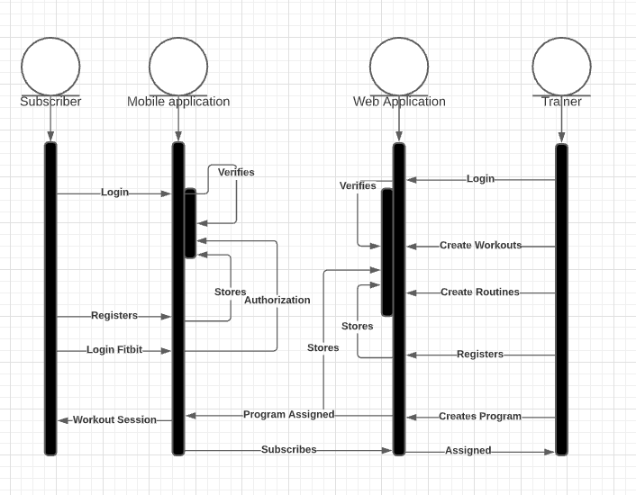

**5.1 Preliminary Design**

Initial primary color was #BAC0FF and a black font color of #000000, with whites of #F0F4F8. Color scheme was then presented to a user with said color codes. Please refer to the image below. User explained that the colors made the application seem “Very outdated”. The application seemed element of an early 2000’s app design wise. Color choices were then revisited. Research was done and it was shown “Dark Mode” was a very popular trend in 2020 for websites. Color scheme below was chosen to showcase this theme.

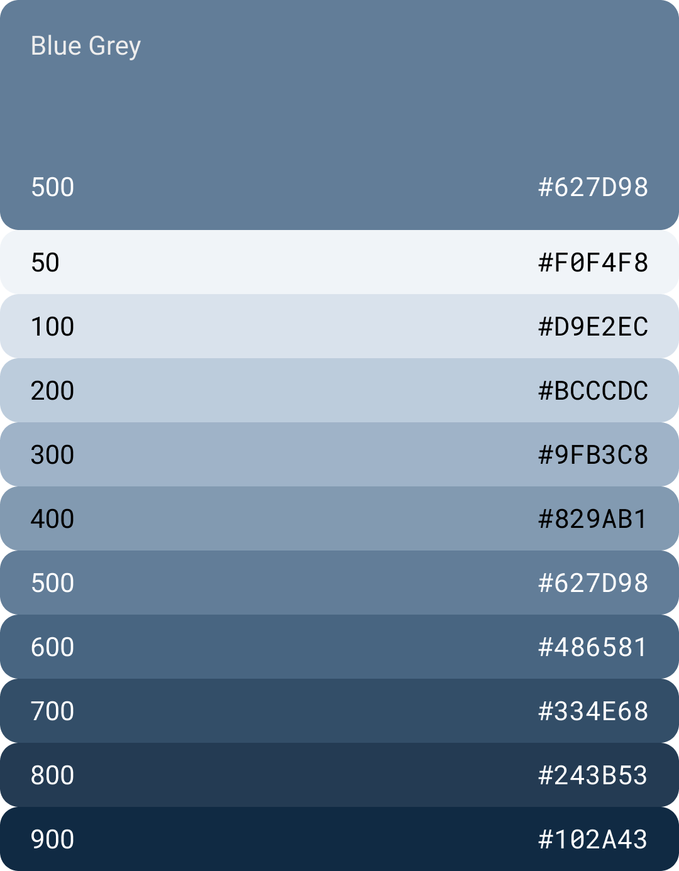

**5.2 User Effort Estimation**

Project duration is 16 weeks. A minimum of eight hours per week is required for the project. Rough estimate of total hours that will be needed for this project is 160 hours. 128 hours are the minimum required hours per week and 32 hours committed for project management meetings twice a week for an average duration of one hour. There will be a total of nine sprints. The first sprint will be one week to kick things off, and the following 8 sprints will last two weeks.

**6.1 Entity Relationship Diagram**

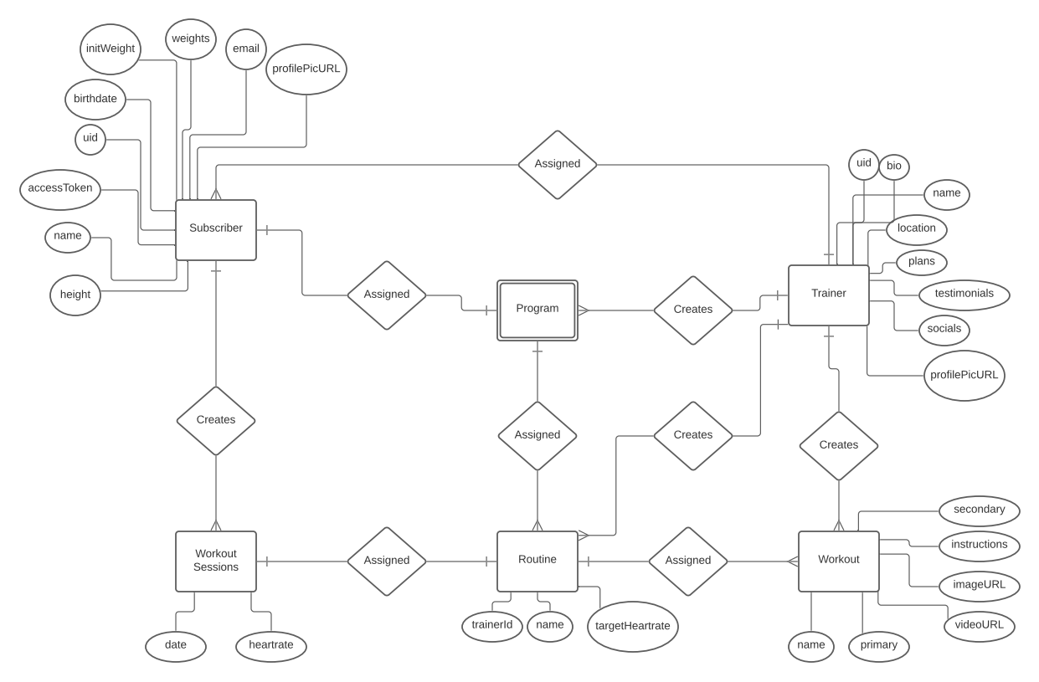

**7.1 Sequence Diagram**



**7.2 Interface Specification**

Web application was to have a dashboard for easy navigation. Dashboard buttons included, clients, workouts, and routines. Upon clicking each one, it would take you to the respective page. Navbar also included for easy and quick navigation. In the clients page. Each client will have a details button containing their heart rate response to the programs. The routine page will have the ability to create a new route via a button. These routines will compose workouts stored in the databases. The workouts/exercises will contain an instructional gif on how to perform the exercise. The mobile application consists of three tabs, “Programs, “Search”, and “Profile”. The programs page will contain the workout along with its details, along with a duration. The search page will allow you to look up trainers and subscribe to them for their training and monitoring. The profile page will contain your heart rate response to the workouts as well as your personal information.

**7.3 State Diagram**

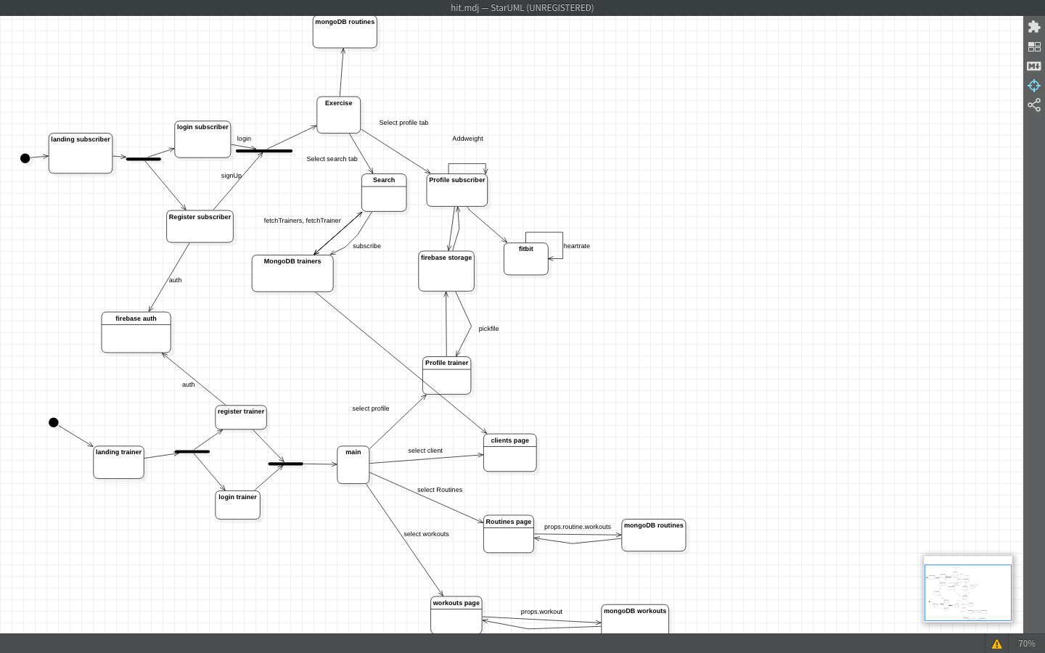

**8. System Architecture and System Design**

**8.1 Subsystems / Component / Design Pattern Identification**

This project required a lot of moving parts in order to meet the requirements of the MVP (Minimum Viable Product). We needed a server/platform to server out frontend and mobile application. A server to hold our backend authentication. A database to store data. As well as a device that can record the user heart rate.

**8.2 Mapping Subsystems to Hardware (Deployment Diagram)**

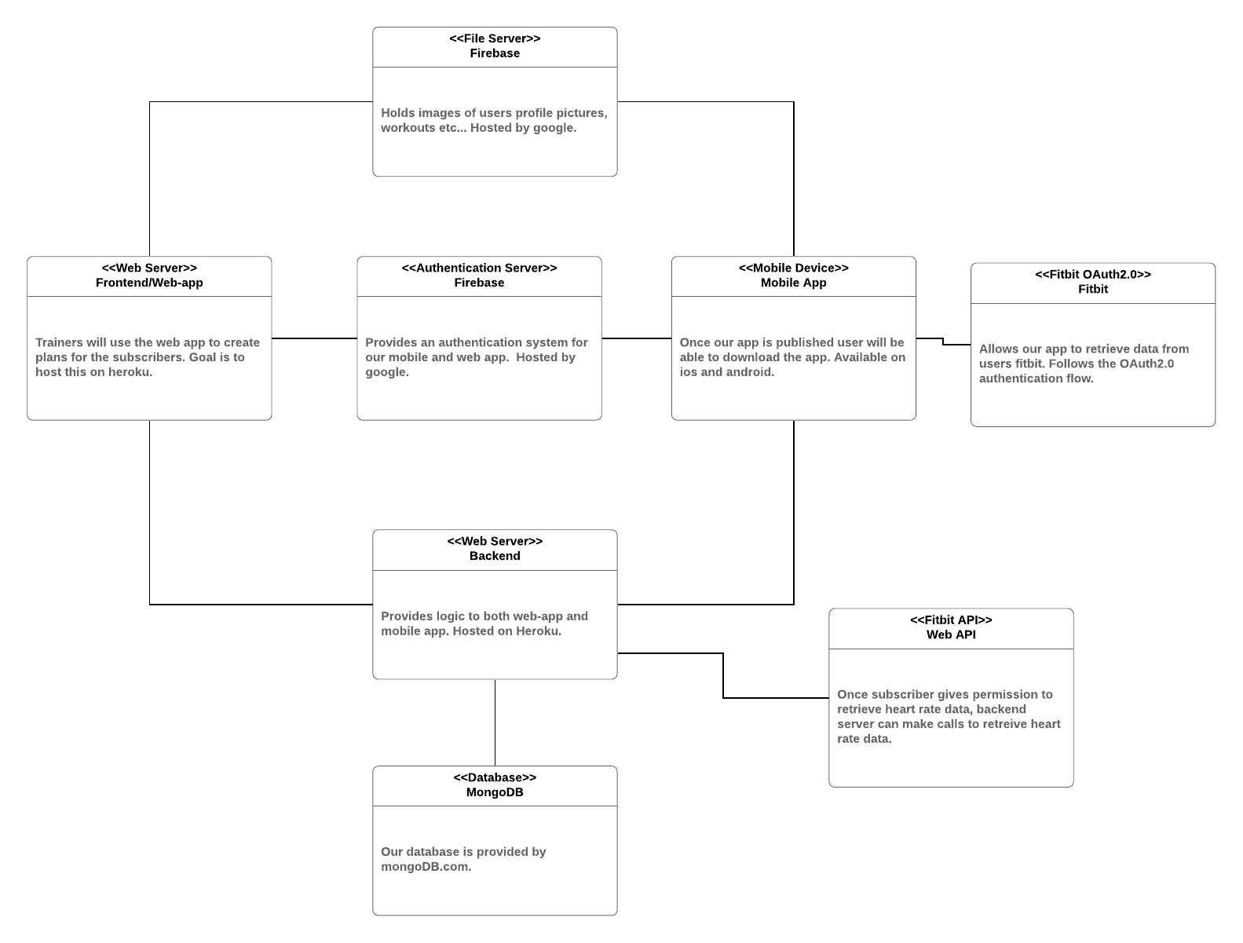

**8.3 Persistent Data Storage**

Our project wouldn’t be complete without a reliable database. The team had a variety of experiences of using both SQL and noSQL databases. We ended up choosing mongoDB as our database because of the beautifully written library mongoose.js.Mongoose provides a nice interface when interacting with mongo. Methods were easy to use. Library is popular, meaning there’s a lot of support from the community. Documentation was nice and concise.

**8.4 Network Protocol**

* TCP/IP
* HTTP
* HTTPS
* FTP

**9.1 Algorithms**

The type of algorithms we used are helper functions. For the mobile side of the project some of the helper functions that we used for the mobile side was calculate duration which calculates the duration of the workout session. The other helper function of the mobile side is the fitbit function which lets the user connect to the fitbit. For the webapp we use some functions like pickfile which would select a picture from the firebase storage and it would help with the profile picture. The other helper function for the web app is createRoutine which helps create a routine for the trainer. These are some of the helper functions that we used to create the project.

**9.2 Data Structures**

For the type of data structures we used for the project were arrays in order to retrieve items from the database like the different routines and workouts. The other data structure we use key value pairs which let specify different objects like the name of the workouts and the name of the trainers.

**10.1 UI Design**

For the web application, UI design involved a dashboard with three navigational buttons. Next page that was worked on was the clients page. This clients page will allow the trainer to view their assigned subscribers. There will be a button that allows the trainer to view additional details about the client, such as weight, date of birth, as well as height on a separate page. This page will also display the client's heart information as well as graph information for assistance with heart rate analysis. It will also give the trainer the ability to assign programs to the client. The workouts page will contain a list of all the added exercises by the trainer. Initially the library of exercises will be empty, but it can be edited and updated over time.

For the mobile application, UI design involved a programs page which is where the subscriber will be conducting their program. Swiping horizontally, will switch to another program assigned by their trainer. There will be a button to initiate the program which contains all the exercises the subscriber will need to do. Towards the bottom of the page there will be a timer to indicate how long the subscriber will be doing the program for. One the timer is over it will switch over to the next exercise the subscriber must do until they finish. UI design also included a search page. This will allow the subscriber to search for a trainer that aligns with their goals. Finally for UI design there will be a profile page where the trainer can update their information for their trainer and their own use.

**10.2 UI Implementation**

UI implementation was done by first creating wireframes and/or an initial draft of how we wanted a certain page to look like, this was done through Adobe XD. Once agreed upon, the wireframe will then be implemented using React and React Native. The web application CSS was then worked on to further improve the project’s appearance.

**11. Testing**

**11.1. Unit Test Architecture and Strategy/Framework**

The unit test frameworks that were used were javascript based which fits the language that was used to create the app. The frameworks were chai, jest and the built React testing library.

**11.2. Unit test definition, test data selection**

***Backend Unit Tests:***

The unit tests that were written in the backend were for testing API endpoints. Early on in development we tested locally. We made sure that the data that we were receiving were in the correct format with a server response of 200. Later on we had to move our backend to the cloud in order to best suit the needs of the mobile application. We changed the route to a path in heroku (which is where the backend is hosted) and continued to test the endpoints. We noticed an increase in response times which was to be expected and thankfully didn't affect the functionality of the app at all. You can view the tests here: <https://github.com/Rafytafy/Hit-Activity-Tracking/blob/main/backend/unit_tests/api_test.js> ***Webapp Frontend Unit Tests:***

Unit tests written within the frontend of the webapp were created to test to ensure page elements and functions were rendering correctly. These tests were utilized to assist with locating and resolving errors within pages of our application. During the early stages of our project and first implementing Redux into our code, testing our components and functions were crucial both as a check to confirm when everything was operating as expected as well as resolving any issues in a timely manner. The front end unit tests can be found here:

<https://github.com/Rafytafy/Hit-Activity-Tracking/tree/main/frontend/unit_tests>

***Mobile Unit Tests:***

Unit tests for the mobile app were to test the functions that calculated things for the app such as age, heart rate success rate and the average heart rate. These were used after implementing new features to ensure that they still worked as expected to make sure nothing had changed.

https://github.com/Rafytafy/Hit-Activity-Tracking/tree/main/mobile/tests

**11.3. System Test Specification**

* API endpoints
* Components rendering
* Function Accuracy

**12.1 Project Plan**

This project included 7 bi weekly sprints. Specific tasks were listed and set by our team leader for completion each sprint. Our project plan also included splitting up into different teams for the development of this project. Parth and Julian would work on the mobile application, Sam and Daniel would work on the web application, Rafy would work on the backend of this project, and Andrew would work on the UI/UX aspects of this project as well as backend server setup. With this everyone could work on the project in accordance to their strengths. We would also meet one to two times a week to discuss project progress and challenges, as well as constant communication via text through our discord channels. This ensured proper communication in this project to make sure everyone was on the right track.

**12.2 Risk Management**

Risk management included documentation of our work within our work logbook. Tasks discussed and then assigned by our team leader would be documented in our lookbook upon completion. This keeps track of everyone’s work, as well as keeping everyone accountable as well.

**13. References**

1. [**https://reactnative.dev/docs/getting-started**](https://reactnative.dev/docs/getting-started)
2. [**https://reactjs.org/docs/getting-started.html**](https://reactjs.org/docs/getting-started.html)
3. [**https://nodejs.org/en/docs/**](https://nodejs.org/en/docs/)
4. [**https://devcenter.heroku.com/categories/reference**](https://devcenter.heroku.com/categories/reference)
5. [**https://www.adobe.io/xd/uxp/**](https://www.adobe.io/xd/uxp/)